English Page Path : /content/en/us/products/collaboration-endpoints/index

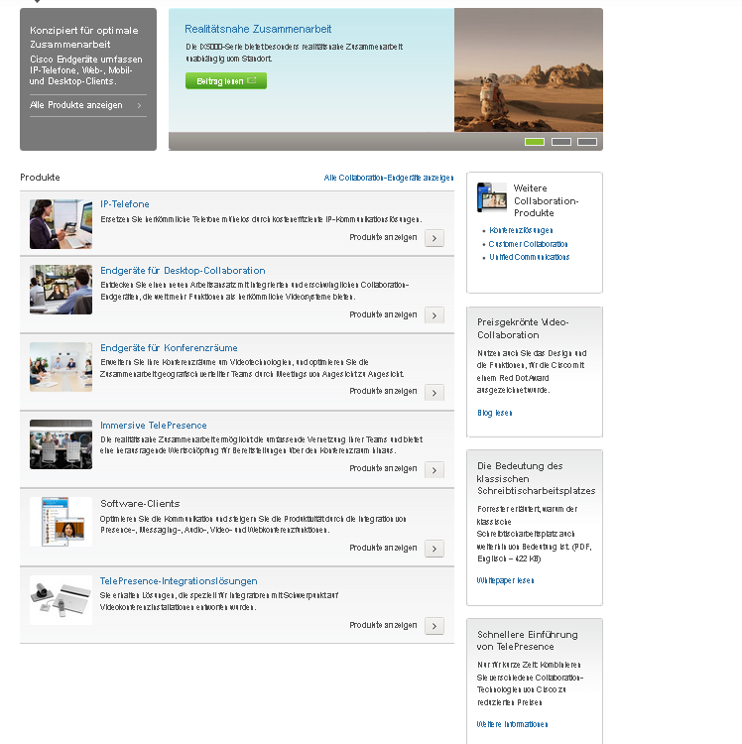

16

17

18

19

10

8

12

11

7

5

4

6

2

1

3

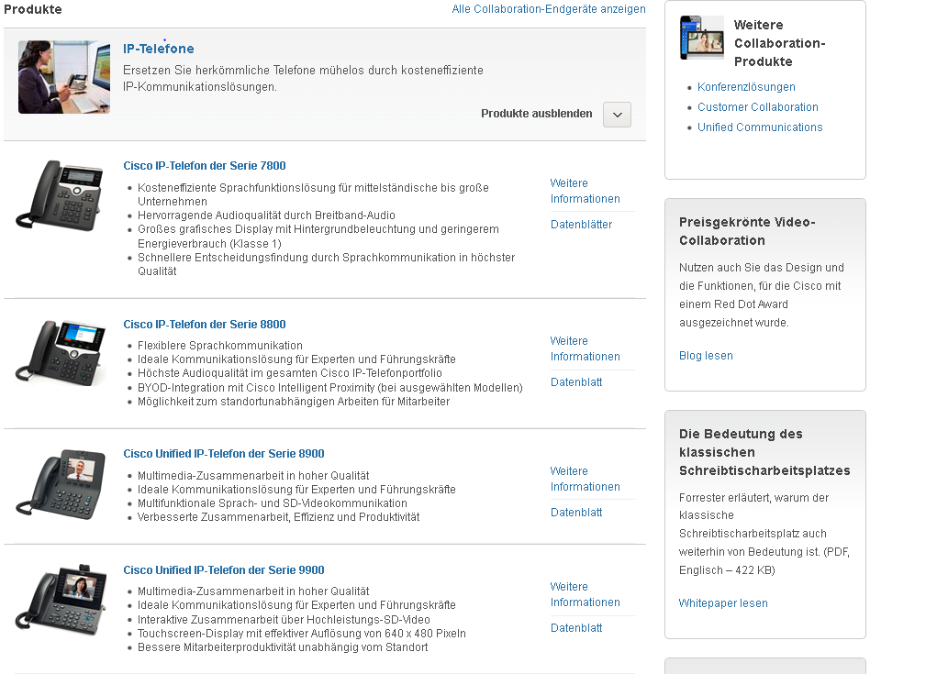

14

13

9

15

15

|  |  |  |  |
| --- | --- | --- | --- |
| 1 | /content/<locale>/products/<product-category>/index/jcr:content/content_parsys/overview/layout-overview/gd12v1/gd12v1-left/primary_cta_v2/title |  | div.c47-pilot  getElementsByTag("h3") |
| 2 | /content/<locale>/products/<product-category>/index/jcr:content/content_parsys/overview/layout-overview/gd12v1/gd12v1-left/primary_cta_v2/description |  | div.c47-pilot  getElementsByTag("p") |
| 3 | /content/<locale>/products/<product-category>/index/jcr:content/content_parsys/overview/layout-overview/gd12v1/gd12v1-left/primary_cta_v2/linktext  /content/<locale>/products/<product-category>/index/jcr:content/content_parsys/index/jcr:content/content_parsys/overview/layout-overview/gd12v1/gd12v1-left/primary_cta_v2/linkurl/url |  | select("div.c47-pilot").select("ul.cta-links").select("li.cta")  getElementsByTag("a").first().text()  getElementsByTag("a").first().attr("href") |
| 4 | /content/<locale>/products/<product-category>/index/jcr:content/content_parsys/index/jcr:content/content_parsys/overview/layout-overview/gd12v1/gd12v1-right/hero_large/heropanel*/title |  | select("div.c50-pilot").first().select("div.frame")  getElementsByTag("h2") |
| 5 | /content/<locale>/products/<product-category>/index/jcr:content/content_parsys/index/jcr:content/content_parsys/overview/layout-overview/gd12v1/gd12v1-right/hero_large/heropanel*/description |  | select("div.c50-pilot").first().select("div.frame")  getElementsByTag("p") |
| 6 | /content/<locale>/products/<product-category>/index/jcr:content/content_parsys/index/jcr:content/content_parsys/overview/layout-overview/gd12v1/gd12v1-right/hero_large/heropanel*/linktext |  | select("div.c50-pilot").first().select("div.frame")  getElementsByTag("a").first().attr("href")  getElementsByTag("b").first().text() |
| 7 | /content/<locale>/products/<product-category>/index/jcr:content/content_parsys/overview/layout-overview/gd12v2/gd12v2-left/drawers_container_*/title |  | doc.select("div.c00-pilot,div.c100-pilot").first().getElementsByTag("h2").text() |
| 8 | /content/<locale>/products/<product-category>/index/jcr:content/content_parsys/overview/layout-overview/gd12v2/gd12v2-left/drawers_container_*/opentext |  | Not able to retrieve this value. Name is null for these tags. |
| 9 | /content/<locale>/products/<product-category>/index/jcr:content/content_parsys/overview/layout-overview/gd12v2/gd12v2-left/drawers_container_*/closetext |  | Not able to retrieve this value. Name is null for these tags. |
| 10 | /content/<locale>/products/<product-category>/index/jcr:content/content_parsys/overview/layout-overview/gd12v2/gd12v2-left/drawers_container_*/headerlinks |  | doc.select("div.c00-pilot,div.c100-pilot").select("div.clearfix").first();  getElementsByTag("a").first().text()  getElementsByTag("a").first().attr("href") |
| 11 | /content/<locale>/products/<product-category>/index/jcr:content/content_parsys/overview/layout-overview/gd12v2/gd12v2-left/drawers_container_*/drawerspanel_*/title  /content/<locale>/products/<product-category>/index/jcr:content/content_parsys/overview/layout-overview/gd12v2/gd12v2-left/drawers_container_*/drawerspanel_*/title/linkurl |  | select("div.series")  getElementsByTag("h3").first()  getElementsByTag("a").first().text()  getElementsByTag("a").first().attr("href") |
| 12 | /content/<locale>/products/<product-category>/index/jcr:content/content_parsys/overview/layout-overview/gd12v2/gd12v2-left/drawers_container_*/drawerspanel_*/description |  | select("div.series")  getElementsByTag("p") |
| 13 | /content/<locale>/products/<product-category>/index/jcr:content/content_parsys/overview/layout-overview/gd12v2/gd12v2-left/drawers_container_*/drawerspanel_*/ parsys-drawers/subdrawer_product_*/highlights |  | select("ul.items")  select("div.prodinfo")  select("ul.details").first().getElementsByTag("li") |
| 14 | /content/<locale>/products/<product-category>/index/jcr:content/content_parsys/overview/layout-overview/gd12v2/gd12v2-left/drawers_container_*/drawerspanel_*/ parsys-drawers/subdrawer_product_*/infolinks |  | select("ul.items")  select("div.prodinfo")  select("ul.infolinks").first().getElementsByTag("li") |
| 15 | /content/<locale>/products/<product-category>/index/jcr:content/content_parsys/overview/layout-overview/gd12v2/gd12v2-left/drawers_container_*/drawerspanel_*/ parsys-drawers/subdrawer_product_*/title |  | select("ul.items")  select("div.prodinfo")  getElementsByTag("h4").first().getElementsByTag("a") |
| 16 | /content/<locale>/products/<product-category>/index/jcr:content/content_parsys/overview/layout-overview /gd12v2/gd12v2-right/htmlblob/html |  | select("div.icon-block") |
| 17 | /content/<locale>/products/<product-category>/index/jcr:content/content_parsys/overview/layout-overview /gd12v2/gd12v2-right/tile_bordered_*/description |  | doc.select("div.c23-pilot, div.cc23-pilot");  select("div.icon-block").remove();  getElementsByTag("p") |
| 18 | /content/<locale>/products/<product-category>/index/jcr:content/content_parsys/overview/layout-overview /gd12v2/gd12v2-right/tile_bordered_*/title |  | doc.select("div.c23-pilot, div.cc23-pilot");  select("div.icon-block").remove();  getElementsByTag("h2") |
| 19 | /content/<locale>/products/<product-category>/index/jcr:content/content_parsys/overview/layout-overview /gd12v2/gd12v2-right/tile_bordered_*/linktext  /content/<locale>/products/<product-category>/index/jcr:content/content_parsys/overview/layout-overview /gd12v2/gd12v2-right/tile_bordered_*/linkurl |  | doc.select("div.c23-pilot, div.cc23-pilot");  select("div.icon-block").remove();  getElementsByTag("a").first().text()  getElementsByTag("a").first().attr("href") |

Deviations:

Additional component exists with class name c42-pilot in the right rail for the below pages

<http://www.cisco.com/web/DE/products/wireless/index.html>

<http://www.cisco.com/web/DE/products/switches/index.html>

<http://www.cisco.com/web/DE/products/routers/index.html>

For the nodes 8 and 9, we are not able to get the content from the tags using Jsoup. This is for all the pages.